NetBeans Usages

Version 1.0
Date 08/11/10

Copyright notice
Copyright © 2010, Cognizione consulting & solutions Pvt Ltd
All rights reserved.

These materials are confidential and proprietary to Cognizione consulting & solutions pvt
ltd/its licensors and no part of these materials should be reproduced, published, transmitted
or distributed in any form or by any means, electronic, mechanical, photocopying, recording or
otherwise, or stored in any information storage or retrieval system of any nature nor should the
materials be disclosed to third parties without the prior express written authorization of
Cognizione consulting & solutions Pvt ltd/its licensors
Revision history

Doc No: | Version no. | Change reference no. | Author | Published date | Sections changed | Description of changes
 | 1.0 |  | Dikshit Rajkhowa | 08/11/10 |  | Base Document

CONTENTS

Purpose of the document 4
Scope of the document 4
Desired outcome 4
Targeted recipient 4
Prerequisite 4
Required Software 4
Adding a Third Party Library 4
Adding a JAR File 7
Adding Hibernate Support 9

FIGURES USED

Figure 1 : Adding a Library 5
Figure 2 : Available libraries 6
Figure 3 : Importing library 7
Figure 4 : Adding a JAR File 8
Figure 5 : Selecting the proper JAR File(s) 9
Figure 6 : Adding Hibernate Support 10

Purpose of the document

This document describes the following

- Common NetBeans IDE 6.5.1 usages.

Scope of the document

This document only explains some common usages using NetBeans IDE 6.5.1. It doesn’t explain the following points

- Programming practices
- Installation and configuration of NetBeans
- Description on different frameworks.

Desired outcome

- Using NetBeans IDE 6.5.1 to work with different frameworks and other common usages.

Targeted recipient

Developers using NetBeans IDE 6.5.1

Prerequisite

- Knowledge of Core and Advanced Java
- Knowledge of web application.

Required Software

- NetBeans IDE 6.5.1

Adding a Third Party Library

- Right click on “Libraries” node in the project window, as shown below

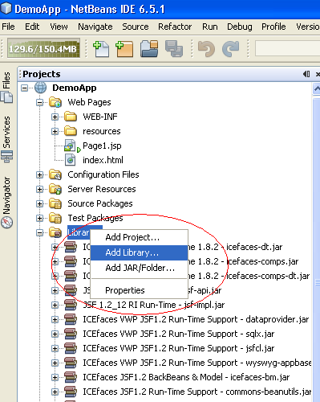

Figure 1 : Adding a Library

- It opens up a small popup window, as shown below
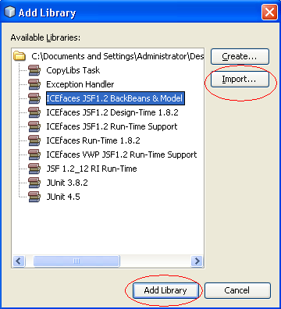

Figure 2 : Available libraries

- If the library is available then click on the “Add Library” button to add the required library, else click on “Import” button which will open up the following popup. Select the library from the popup and click on “Import Library” to import the library.
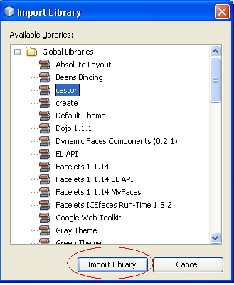

Figure 3 : Importing library

Adding a JAR File

- Right Click on the libraries node in the Project window and click on “Add JAR
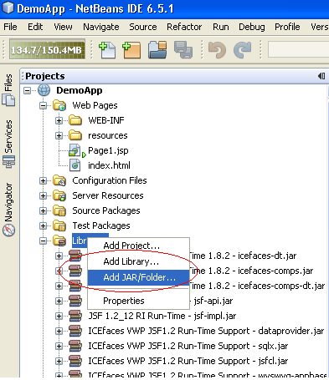

Figure 4 : Adding a JAR File

- This will open up a pop up window navigating the local directory system as shown below. Select the JAR File to add and select on the right hand side “Copy to Libraries Folder”. This will put the JAR files under the “lib” folder of the project. Then click on “Open” to add.

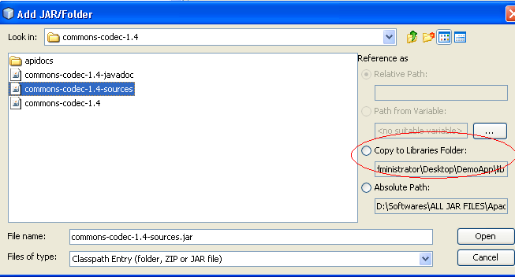

Figure 5 : Selecting the proper JAR File(s)

Adding Hibernate Support

To add Hibernate support follow the steps to add a Library, described above, and add Hibernate
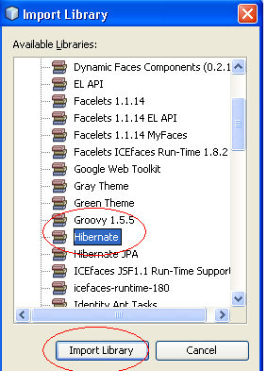

Figure 6 : Adding Hibernate Support

